We have our object detection in two phase. In phase 1, we will be train to detect the object type and size locally on our PC and in phase 2, we will deploy the model on some server and using esp32 WIFI we will access the model and detect the model without using the local system.

**Phase 1: Detection and training of model on local system**

**Step 1: Capture Image from ESP32 + OV7670:** Send grayscale image data from ESP32 to PC via Serial.

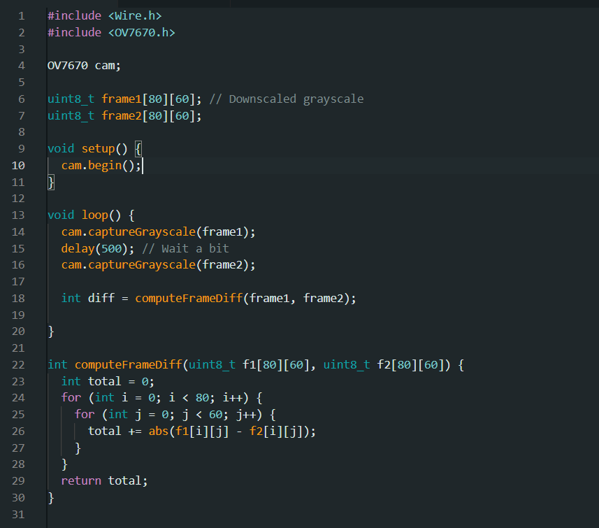

**Step 2: PC Python Script to Receive & Process Frame**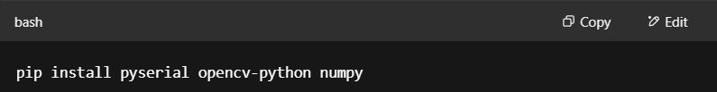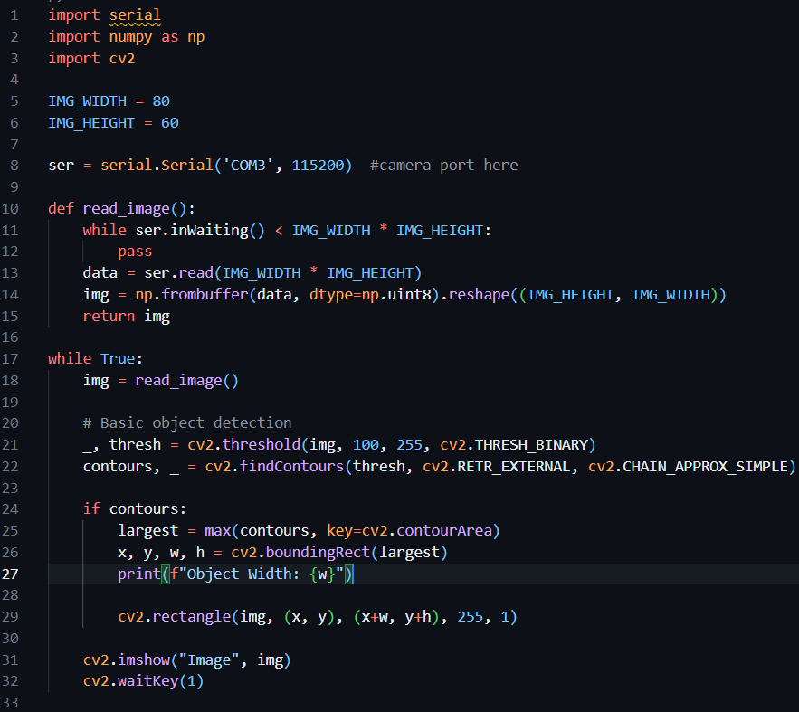

**Phase 2: Server Deployment + ESP32 HTTP Client**

**Step 1: Python Server for Image Upload + Detection**

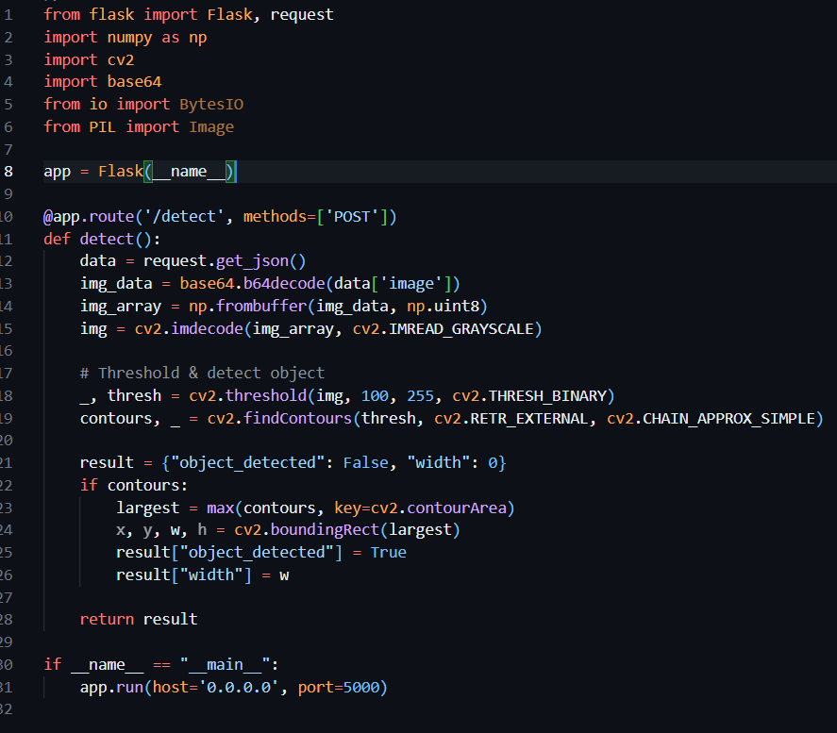

**Step 2: ESP32 Sends Image Over Wi-Fi (HTTP POST)**

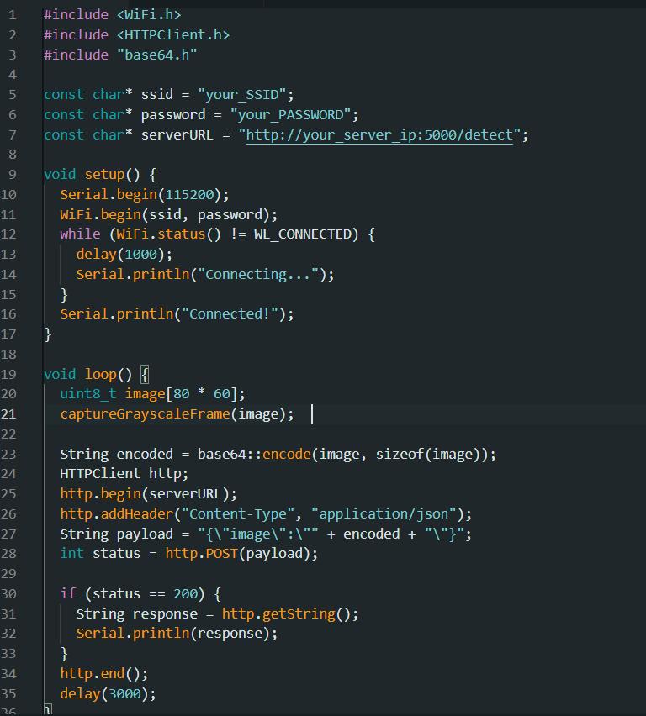

We’ll implement a base64 encoding function.

This process will help us to capture and send images to our server using ESP32 through wi-fi. The server detects the object’s type and its width. ESP32 gets response and will rotate the servo motor which will open the doors.s